|  |
| --- |
| **INFORMATION NOTE**  **11th AFRICA SYMPOSIA ON STATISTICAL DEVELOPMENT (ASSD)**  **AND**  **2nd JOINT SESSION OF THE COMMITTEE OF DIRECTORS-GENERAL OF NATIONAL STATISTICS OFFICES (CoDG) AND THE STATISTICAL COMMISSION FOR AFRICA (STATCOM-AFRICA)**  **LIBREVILLE – GABON**  **23 – 28 November 2015**  **Sino-Gabonese Friendship Stadium, Akanda, Gabon**  **11th ASSD internet site:** [**http://www.stat-gabon.com**](http://www.stat-gabon.com) |

1. ORGANISATION AND COORDINATION

The meeting is jointly organized by the African Union Commission (AUC), the UN Economic Commission for Africa (UNECA), the African Development Bank (AfDB), the UN Population Fund (UNFPA), the Gabonese Government, Statistics South Africa (Stats SA) represented by the ASSD Secretariat and other statistical partners.

The main resource persons are as follows:

1.1 ASSD Secretariat

**Ms Nwabisa Maya**

Statistics South Africa  
Pretoria, South Africa  
Tel: (+27) **12 310 2126**

: (+27) **84 631 0168**

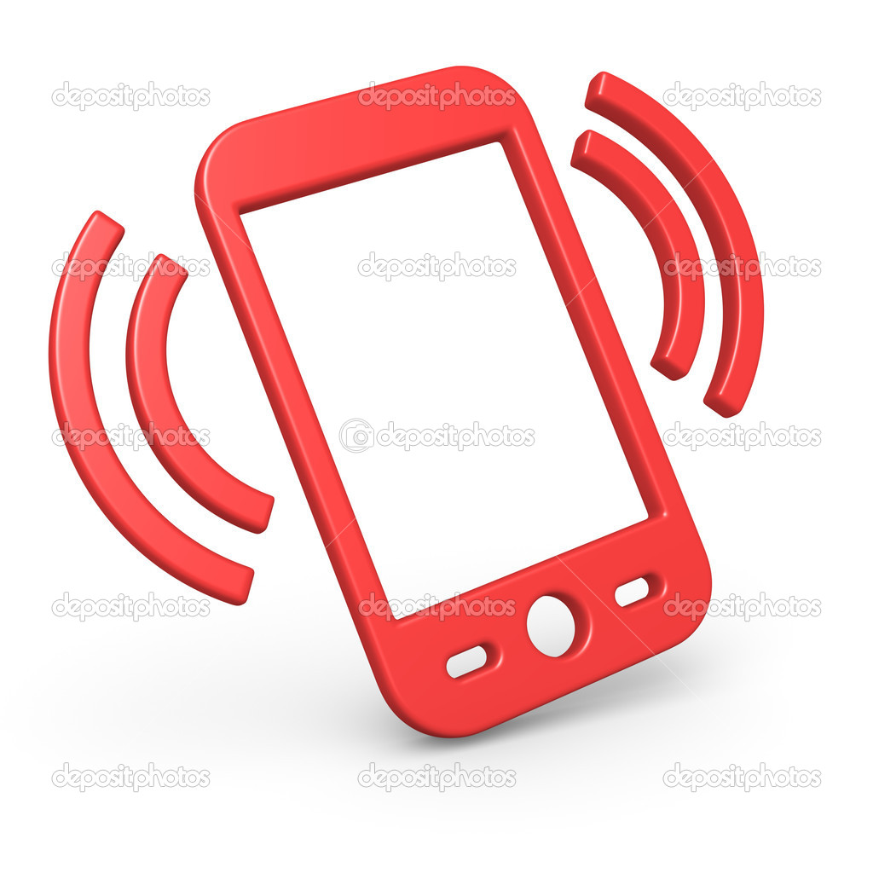

E-mail: [nwabisam@statssa.gov.za](mailto:nwabisam@statssa.gov.za)

Fax: (+27) **12 310 4878**

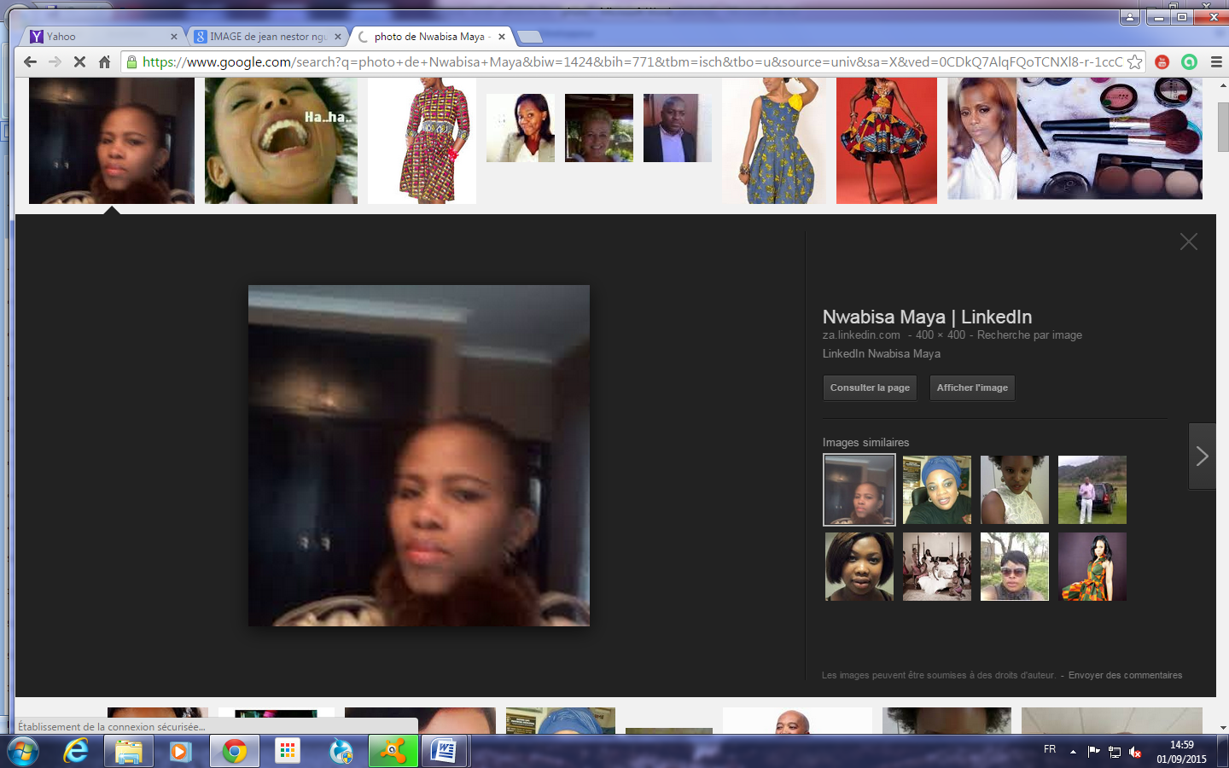

1.2 Host country coordinator

**Mr Jean Nestor Nguema**

Direction Générale Adjoint de la Statistique

: (+241) **07 39 65 83**



E-mail: [nguemamebane@yahoo.fr](mailto:nguemamebane@yahoo.fr)

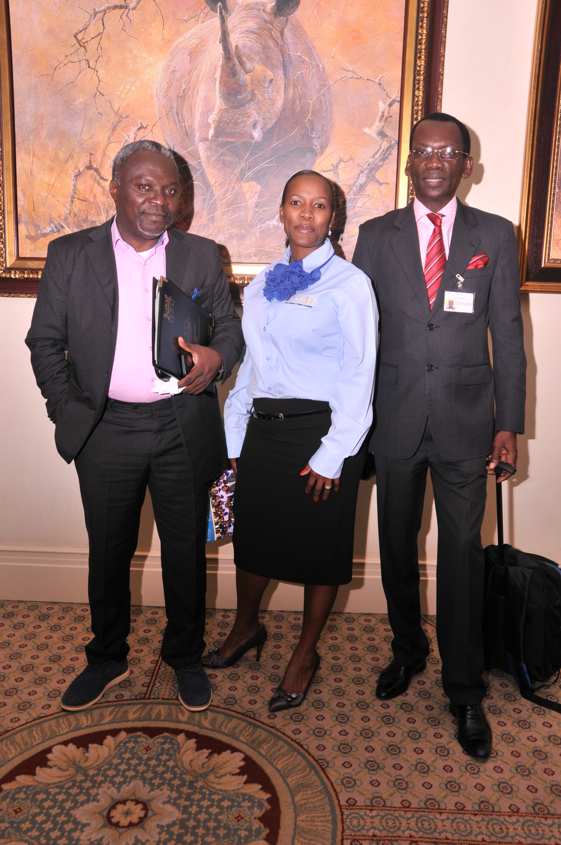

1.3 Other contacts

**Ms Wynnie Mboumba**

(+241) 07 653 110



E-mail: [mwynnie@gmail.com](mailto:mwynnie@gmail.com)

2. THEME, VENUE AND DATE OF SYMPOSIA

2.1 Theme

The proposed theme for the 11th Africa Symposia on Statistical Development is "**Promoting Use of Information and Communication Technology Solutions in Improving CRVS in Africa**".

2.2 Venue and date

The conference will be held at Angondjé (Akanda City) from 23 to 28 November 2015 at the Sino-Gabonese Friendship Stadium

As a fringe event of the symposia (prior and after), other meetings will be held on the same site:

* From 16 to 20 November 2015: The seminar on "Africa Information Motorway Implementation" organized by the AfDB
* From 21 to 22 November 2015: "African Conference for Official Statistics Transformation" organized by the UN Statistics Division, Statistics Canada and Eurostat
* From 26 to 28 November 2015: The second joint meeting of the African Union Committee of Directors-General of National Statistics Offices (CoDG) and the Statistical Commission for Africa (Statcom-Africa) on the theme "Data Revolution, Sustainable Development Objectives, and the Africa 2063 Agenda"
* Meeting on the theme "Regional Strategy for Statistics Development in the Central African States Economic Commission (CASEC) organized by CASEC
* Training workshop on research statistics and technological innovation in Africa, organized by NEPAD.

3. AIRPORT ARRIVALS AND TRANSPORT ARRANGEMENTS

Transport from and to the airport will be organized by the National Coordination Committee. In case of emergency concerning transport issues, you are requested to communicate with the Secretariat using the numbers above. Participants will have to provide their trip information (arrival and departure) to the people whose contacts are mentioned above.

As soon as you leave your country, please have your luggage identified by affixing a badge or stickers and writing "Gabon 11th ASSD Symposia". This will allow identification and retrieval of your luggage at Libreville airport and will make it easier for the welcoming committee to convey your luggage while your travel documents are being verified.

A reception desk will be available upon your arrival at the airport to welcome you and show you to the vehicles that have been assigned for the event. The ASSD reception desk will provide the delegates with the necessary information. Some vehicles will be available at the airport to transport the delegates from Libreville airport to their respective hotels. This service will help the delegation to complete the administrative formalities. Delegates are therefore requested to provide the exact arrival dates and times in Libreville. Also, on their arrival they have to wait until the host has contacted them to explain certain protocols. It is therefore necessary that all delegates or development and technical partners transmit the details of their trip to the ASSD Secretariat and the host country coordinator before 9November in order to arrange transport facilities. The vehicles booked for the participants' transport from Libreville airport to their respective hotels will be available from 20 November 2015.

For further details prior to your arrival at Libreville airport, you could directly visit the Libreville airport website or the following link: http: //www.adlgabon.com/fr/contacts.php

4. HOTEL ACCOMMODATION

The delegates are expected to be accommodated in the hotels below as indicated in the cities of Libreville and Akanda, not far from the symposia venue. Delegates are requested to comply with the choice of hotels as well as with the transport arrangements related to the hotels. Should a delegate wish to choose his own accommodation other that those indicated below, such delegate will have to make his/her own transport arrangements to the symposia venue.

In all these hotels, including restaurants, payment can be made in Euro, in US Dollars and you can receive CFA francs in return. In some of those hotels, currency exchange is possible (Euros, US Dollars).

The prices of the rooms in red are those that have been negotiated with the hotels. Breakfast is included. This arrangement has been agreed upon between the hotels and the Gabonese General Directorate of Statistics.

|  |  |  |  |  |  |  |  |  |  |
| --- | --- | --- | --- | --- | --- | --- | --- | --- | --- |
| **No.** | **Hotel** | **Classification** | **Type of room** | **P.U.** | **Unit price**  **with discount** | **Quantity** | **Place** | **Address** | **Remarks** |
| 1 | **MERIDIEN**  **RE-NDAMA** | *5-stars* | Classic | 180 000 | 114 000 | 46 | Glass | (+241) [79 32 00](tel:79%2032%2000)/  79 30 42  www.lemeridienrendama.com | 1. Breakfast included 2. Security firm 3. Infirmary 4. Internet |
| Superior | 190 000 | 124 000 | 70 |
| Standard Executive | 210 000 | 144 000 | 10 |
| Luxury executive | 240 000 | 159 000 | 15 |
| Junior suite | 242 000 | 168 000 | 2 |
| Diplomatic suite | 380 000 | 264 000 | 3 |
| Executive suite |  | 219 000 | 2 |
| Presidential suite | 710 000 | 529 000 | 2 |
|  | | | | | | | | | |
| 2 | **PARK INN** | *4-star* | King-size bed | 150000 |  | 70 | Kalikak | (+241) 01 44 80 00 /  05 40 57 79  <http://www.hotelsone.com/>  or  parkinn.com/hotel-libreville | 1. Breakfast included 2. Security firm 3. Infirmary 4. Internet |
| Standard twin beds | 150000 |  |
| Double | 1635000 |  |
| Suite king-size bed | 195000 |  |
| Suite 1 room | 415000 |  |
|  | | | | | | | | | |
| 3 | **NOMAD**  **Residence suites** | *4-star* | Suite | 131 000 |  | 42 | Okala | (+241) 7 65 24 80/  05 65 24 80  www.nomad-residence-hoteliere.com | 1. Breakfast included 2. Security firm 3. Pharmacy first aid 4. Internet |
|  | | | | | | | | | |

|  |  |  |  |  |  |  |  |  |  |
| --- | --- | --- | --- | --- | --- | --- | --- | --- | --- |
| **No.** | **Hotel** | **Classification** | **Type of room** | **P.U.** | **Unit price**  **with discount** | **Quantity** | **Place** | **Address** | **Remarks** |
| 4 | **ONOMO** | *3-star* | Standard | 82 000 |  | 114 | Sablière | (+241) 45 91 00  www.onomohotel.com/-ONOMO-Libreville | 1. Breakfast not included 2. Pharmacy first aid 3. Internet |
| Handicapped | 91 000 |  | 2 |
| Suite | 121 000 |  | 2 |
|  | | | | | | | | | |
| 5 | **L'ETOILE D'OR**  **(sablière)** | *3-star* | Standard | 108 000 |  | 25 | Sablière | (+241) 44 69 80  www.etoiledorhotel.com | 1. Breakfast not included 2. Security firm 3. Pharmacy first aid 4. Internet |
| Superior | 118 000 |  | 31 |
| Handicapped | 118 000 |  | 2 |
| Royal club | 138 000 |  | 10 |
| Twin | 158 000 |  | 10 |
| Junior suite | 228 000 |  | 3 |
|  | | | | | | | | | |
| 6 | **L'ETOILE D'OR**  **(London**) | *3-star* | Superior | 89 000 |  | 10 | London | (+241) 06 08 58 42/ 04 43 84 24  www.etoiledorhotel.com | 1. Breakfast not included 2. Security firm 3. Internet |
| Standard | 79 000 |  | 10 |
|  | | | | | | | | | |
| 7 | **ADAGIO** | *3-star* | Classic | 76 000 |  | 5 | Face BBS | (+241) 01 76 31 13  www.infoshoteladagio@gmail.com | 1. Breakfast not included 2. Internet |
| Superior | 91 000 |  | 5 |
|  | | | | | | | | | |

|  |  |  |  |  |  |  |  |  |  |
| --- | --- | --- | --- | --- | --- | --- | --- | --- | --- |
| **No.** | **Hotel** | **Classification** | **Type of room** | **P.U.** | **Unit price**  **with discount** | **Quantity** | **Place** | **Address** | **Remarks** |
| 8 | **HELICONIA** | *3-star* | Single room | 70 000 |  | 74 | Angondjé | (+241) 01 45 11 46/  01 45 11 4647/  05 45 32 45/  07 51 84 62 (Mr Koumba)  http://heliconiahotels.com | 1. Breakfast not included 2. Pharmacy fisrt aid 3. Shuttle transport 4. Internet |
| Classic (2) | 70 000 |  |  |
| Junior suite | 95 000 |  |  |
|  | | | | | | | | | |
| 9 | **L'ORCHIDEE** | *2-star* | Economic | 45 000 |  | 8 | Okala face ballon d'or | www.hotel-orchidee-gabon.com | 1. Breakfast not included 2. Pharmacy first aid 3. Security firm 4. Internet |
| Comfort | 55 000 |  | 9 |
| Business | 65 000 |  | 10 |
| With 2 beds | 75 000 |  | 4 |
| Luxury | 85 000 |  | 6 |
|  | | | | | | | | | |
| 10 | **SOLEINA** | *2-star* | Single room | 45 000 |  | 58 | Angondjé | (+241) 05 38 66 68  www.hotelsoleina.com | 1. Breakfast not included 2. Security firm 3. Pharmacy first aid 4. Internet |
|  | | | | | | | | | |
| 11 | **NGONEMONO** | *2-star* | Standard (1) | 40 000 |  | 15 | Lac bleu | (+241) 01 44 13 38 / 05 93 61 21  www.hotel-ngonemono.com | 1. Internet 2. Medical assistance 3. Shuttle (18-seater) 4. Breakfast not included |
| 50 000 |  | 2 |
| Standard (2 beds) | 40 000 |  | 1 |
| Dormitory room | 100 000 |  | 3 |
| Suite | 60 000 |  | 2 |
| 75 000 |  | 1 |
|  | | | | | | | | | |

|  |  |  |  |  |  |  |  |  |  |
| --- | --- | --- | --- | --- | --- | --- | --- | --- | --- |
| **No.** | **Hotel** | **Classification** | **Type of room** | **P.U.** | **Unit price**  **with discount** | **Quantity** | **Place** | **Address** | **Remarks** |
| 12 | **APPART. VERONIQUET CHRISTINE** | *2-star* | Standard apartment (1 room) | 51 000 |  | 8 | Face CES | (+241) 06 03 82 05  www.residenceveroniquechristine.com | 1. Internet 2. Satellite channels 3. Pool 4. Shuttle 5. Exchange bureau 6. Breakfast not included |
| Suite apartment (1 room) | 61 000 |  | 4 |
| 81 000 |  | 2 |
| Presidential suite (2 rooms) | 105 000 |  | 1 |
| 251 000 |  | 1 |
|  | | | | | | | | | |
| 13 | **HIBISCUS** | *2-star* | Standard | 42 000 |  | 31 | BLVD Triomphal | (+241) 07 87 10 70www.hotelhibiscusgabon.com | 1. Internet 2. Satellite channels 3. Breakfast not included |
| Mini suite | 52 000 |  | 3 |
| Suite | 62 000 |  | 4 |
|  | | | | | | | | | |
| 14 | **S.E.H.G HOTEL GLASS** | *High standing* | 101 to 108 | 40 000 |  | 5 |  | (+241) 07 15 16 55  www.hotel-orchidee-gabon.com | 1. Internet 2. Satellite channels |
| 201 to 216 | 50 000 |  | 5 |
| 208 to 215 | 60 000 |  | 5 |
|  | | | | | | | | | |
| 15 | **CLEON** | *High standing* | Standard | 35 000 |  | 4 | Louis | (+241) 07 39 81 80 motelcleon@hotmail.com | 1. Internet 2. Satellite channel 3. Breakfast not included |
| Standard | 40 000 |  | 2 |
|  | | | | | | | | | |
| 16 | **LA PATIO** | *High standing* | Standard (1) | 45 000 |  | 13 | Louis | (+241) 07 28 87 94  www.hotel-lepatio.com | 1. Internet 2. Satellite channels 3. Breakfast not included |
| Standard (2) | 55 000 |  | 3 |
| VIP | 60 000 |  | 3 |
| VIP luxury | 65 000 |  | 2 |
| Suite | 90 000 |  | 2 |

The hotels costs indicated above are comprised between 45 000 CFA francs and 710 000 CFA francs (all taxes and service expenses included). They are the lowest rates among the hotels located not very far from the symposia venue. Added to the accommodation cost, all the participants will be responsible for further costs like phone, internet/fax, floor service, mini-bar and laundry, further meals (lunch and dinner). Tea and lunch breaks will be served at the symposia venue.

Participants are urgently requested to inform the ASSD Secretariat or the National Organisation Committee of their choice of accommodation 3 weeks prior to the conference.

5. PROGRAMME FOR 11th ASSD SYMPOSIA AND 2nd JOINT SESSION OF CoDG/STATCOM

A copy of the 11th ASSD Symposia Working Programme will be available on the ASSD website. All delegates who will be making presentations must submit the copies of their documents to the ASSD Secretariat prior the symposia dates via the Secretariat and other resource persons. The technical communication aids that are available will be communicated to the presenters.

6. VISA REQUIRMENTS TO SECURE ENTRY INTO GABON AND POLICE FORMALITIES

Participants coming from countries that have diplomatic representation in Gabon will have to go to their embassy to complete administrative formalities for obtaining a visa. In other respects, the Gabonese consular services abroad require visa applicants to personally apply for a visa.

The visa is either free of charge or to be paid depending on the type of passport or according to the country. The documents required by the air and frontier police agents are: **entry visa, entry permission**.

6.1 Countries needing and not needing a visa

The table below shows **the countries that require an entry visa in Gabon and the required documents before participants will be allowed into the country:**

| **Type of document** | **Country** | **Visa amount** |
| --- | --- | --- |
| **Diplomatic passport** | Benin, Sénégal, Tunisia, Guinea Conakry, Djibouti, Burkina Faso, Egypt, Mali, Morocco, Rwanda, Senegal, Democratic Republic of Congo, Côte d'Ivoire, Mali, Cameroon, Benin, Equatorial Guinea, Central African Republic, Chad | **45 000 FCFA ( 85 $)** |
| **Service passport** |
| **International vaccine book** |

Some countries do not need any visas in the framework of the bilateral agreements with Gabon. Please obtain this information beforehand to ensure that you are granted access to the country.

The board below indicates the **countries that do not require an entry visa into Gabon, and the type of passport.**

| **Type of document** | **Country** |
| --- | --- |
| **Diplomatic passport** | South Africa, Morocco, Mauritius |
| **Service passport** |
| **Ordinary passport** |
| **International vaccine book** |

6.2 Visa for international organisations

The residents of the countries having a diplomatic or service passport do not need a visa. International civil servants of organizations benefit from the status of the countries in which they live, for example Central African States Bank civil servants benefit from Cameroon visa supply terms; that's to say, having a diplomatic or service passport. Participants have the possibility to take an ordinary visa in the Gabonese diplomatic representation abroad.

Note: Organization members (ADB, AFRISTAT, UNICEF, FNUAP, etc.) are subject to visa formalities of the countries in which they are settled.

6.3 Countries that do not have diplomatic representation in Gabon and delegations that do not have a visa upon departure

Delegates who have not been able to obtain a visa in the Gabonese diplomatic representations of their respective countries will be able to get it at the airport. **However, the amounts indicated may vary**. Participants who are unable get a visa in their home country before their departure will receive an invitation from the DGS in Gabon that they will present at the airport police station in Libreville.

For those countries that do not have diplomatic representation in Gabon, if possible, visit the visa request service on line: http.//www.dgi.ga/e-visa . It offers facilities at your arrival at Libreville airport. **The amount to be paid is 55 000 CFA francs (45 000 CFA francs for the visa and 10 000 CFA francs for use expenses).**

7. HEALTH AND SAFETY

7.1 Health measures

The compulsory vaccines to enter Gabon are as follows:

| **Type of pathology** | **Type of vaccine** |
| --- | --- |
| Yellow fever | Stamaril |
| Thyphoid fever | Typhim VI |
| Meningitis | Meningo |
| Tetanus | Dultavax |
| Hepatitis B | Shanvac |
| Tuberculosis | BCG |

Delegates are urgently requested to check in at their embassies or nearest hospital services to obtain all information pertaining to health precautions that may be useful for the trip.

7.2 Emergency health service

|  |  |  |  |
| --- | --- | --- | --- |
| **Structures** | **Contacts** | **Service** | **Observations** |
| Central university hospital, Libreville (CHUL) | (+241) 06 00 79 55/06 00 80 56 | 24/24 | Reference hospital/ Emergency service |
| Central university hospital, AGONDJE (CHUA) | (+241) 01 45 90 00 | 24/24 | Located near the symposia venue |
| Military hospital | (+241) 01 79 38 24 | 24/24 | Reference hospital/ Emergency service |
| El RAPHA | (+241) 07 98 66 60 | 24/24 | Private clinic |
| Clinique vie verte | (+241) 06 42 44 40/07 84 50 23 | 24/24 | Private hospital |
| SOS Médecins | (+241) 01 74 08 80/ 07 67 67 76 | 24/24 | Private |
| SMUR (Service mobile d'urgence et de réanimation-CNSS) | N° vert : (+241) 1333  06 00 90 13 | 24/24 | Emergency service |
| **Structures** | **Contacts** | **Service** | **Observations** |
|  |  |  |  |
| Union médicale | (+241) 01 73 70 85/ 06 24 91 25 | 24/24 | Clinic |
| Clinique MIA | (+241) 07 03 50 70 / 01 77 25 45 | 24/24 | Clinic |
| SAMU (Service d'aide médicale d'urgence) | (+241) 1300 - (+241) 01 76 06 73- 06 26 68 64 | 24/24 | Emergency service |
| Red Cross | (+241) 03 21 02 32-03 31 70 23 | 24/24 | Emergency service |

7.3 Instructions and guidelines in terms of safety

Safety services will be provided from the airport to the symposia venue and accommodation venue for VIP participants. They are also requested to carry traveller's cheques. It is advisable not to countersign the cheques until you really need to use them. Make sure you only carry what you need, store most traveller's cheques safely at the hotel in the strongboxes available to you.

Write down your credit cards numbers, the customer service numbers of the transmitting banks, etc. Put the note in a sealed envelope and ask the hotel receptionist to keep it for you or leave it in the strongbox of your hotel room.

During your whole stay in Libreville and Akanda, you must comply with the following instructions:

* Wear your badge all the time and everywhere you go;
* Avoid attracting attention by wearing excessive jewellery, cameras and other precious objects;
* Always keep an eye on everything happening around you;
* If you want to call a taxi, your hotel or nearest tourist information desk can recommend you a reliable service;
* Never go out alone late at night;
* Inform the members of the National Organization Committee about any transactions away from the hotel and Sino-Gabonese stadium at Angondjé (symposia venue);
* Don't drink alcohol at the symposia venue;
* Inform the security agents about incidents, accidents or muggings, etc.

7.4 Prohibited behaviour or actions in the Gabonese Republic

The following may be considered as a breach of the law:

* Possession of, trade in and/or using drugs (cannabis, Indian hump, etc.);
* Sexual intercourse with minor children;
* Internet site visits to pages or images on paedophilia are considered a cyber crime in Gabon;
* Possession of firearms or side-arms (e.g. handguns, knives) without authorisation is prohibited in Gabon.

8. LANGUAGE

The workshops during the symposia are both in English and French with simultaneous translation services.

9. EXCHANGE CURRENCY

The CFA francs is the currency used in Gabon; common to several countries of the Central African Economic and Monetary Community (Cameroon, Equatorial Guinea, Republic of Congo, Chad ) Its code is XAF. The exchange rate of different currencies (Euro, US Dollars ($, US$), CAD, JPY, etc.) are as follows:

* 1 Euro = 655,957 CFA francs
* 1 USD = 738,215 CFA francs (parity is variable in accordance with the Euro)
* 1 CAD = 477,245 ( CFA francs
* 100 JPY = 583,398 CFA francs

A foreign currency bureau de change is available at Libreville airport, but there are other places where exchange is made at no cost. However, the bureau de change is exclusively located in the counters of great banks and in big international hotels. The working hours for all big banks are: 7:30 to 11:30 and from 14:30 to 16:30 (Monday to Friday) .

At Libreville airport, there are bank cash points or ATMs: BICIG; BGFIBank, Ecobank, UGB. These various cash points are compatible with VISA international cards. You can get further information at the hotel reception.

10. INTERNET

Internet will be available for use by delegates during the conference. Technicians will also be available to help the delegates and answer all possible questions.

11. EXHIBITION

Inquiries on the exhibition can be addressed to the ASSD Secretariat and to the host country coordinator.

12. NEWS BULLETIN

In agreement with the ASSD tradition, a daily news bulletin will be produced each day on striking facts of the conference. For more information you can visit the previous news bulletin sessions of the ASSD at www.statssa.gov.za.

13. COMMUNICATION

The international code for Gabon is **241**. The code to call outside is 00 followed by the county code (for example "**00241**" for Gabon).

14. TOURISM

The social programme includes a visit to the following sites: Pongara National Park, which is a protected area covered with forest, savanah, lagoon and bordered by the ocean; the Mondah forest; Sibang arboretum; the artisan village; the National Museum; and the special economic zone at N'kok.

During the symposium, Gabon will play a soccer match on 24 November, which would serve as an eliminatory game for the next World Cup.

15. CLIMATE AND WEATHER FORECAST

Gabon is equatorial, and a hot and damp country. This means that temperatures vary only slightly throughout the year, with alternating dry and rainy seasons. In the rainy season, rainfalls are considerable and make the climate favourable for activities such as agriculture and transport. The average temperatures are between 21°C in the southwest of the country and 27°C on the coast and in the hinterland. The extremes go from 18°C to 36°C. In November, the temperature varies between 23.4°C and 28.4°C. November is considered a period having one of the heaviest rains. The atmospheric humidity rate averages about 85%. It can even reach 100% in the rainy season.

16. TIME ZONE

Time difference with GMT: UTC/GMT + one hour.

We hope that the information provided above will help you prepare for your arrival at the 11th Africa Symposia on Statistical Development (ASSD) and the 2nd Joint Session of CoDG/Statcom-Africa.

**We look forward to welcoming you to Gabon!**

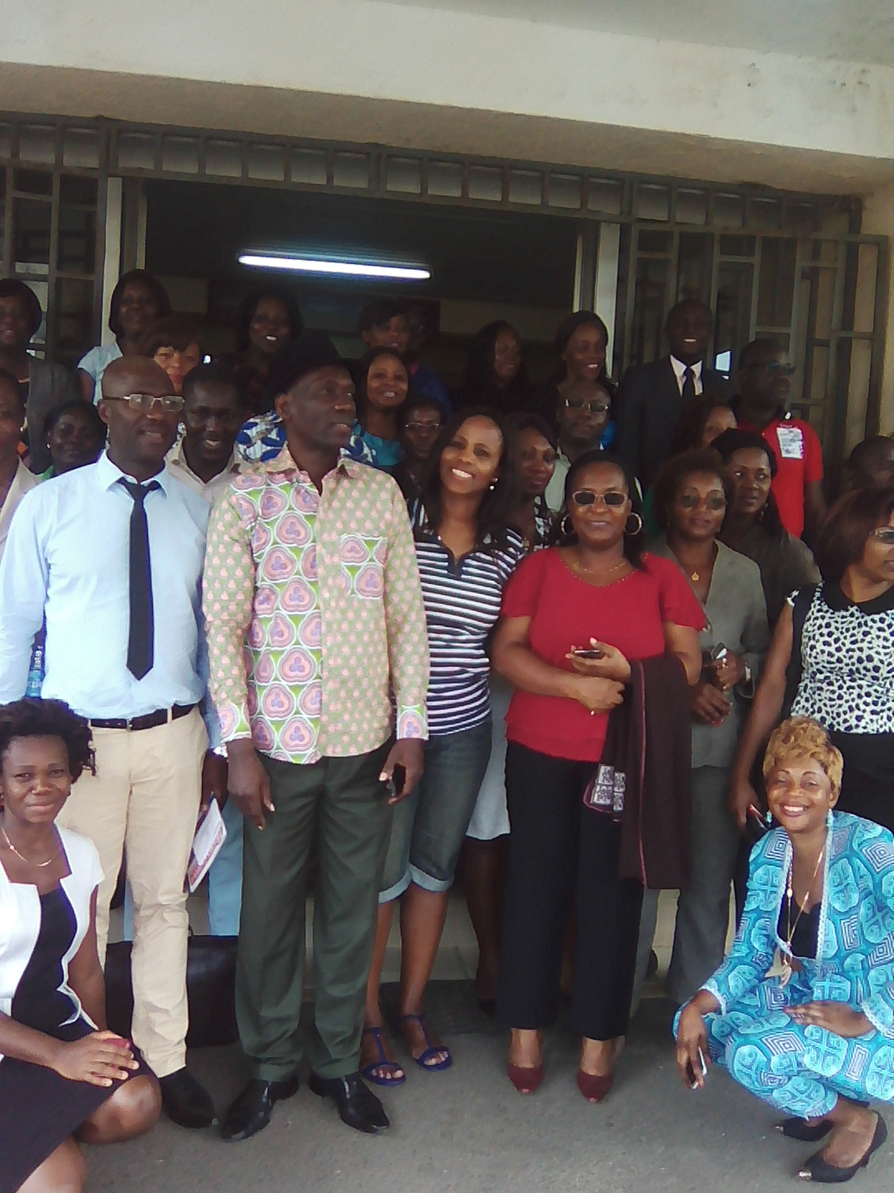

|  |
| --- |
| **A few members of the organization committee for the 11th Symposia in Gabon and the ASSD Secretariat** |